

CUSTOMS & EXCISE DIVISION, P.O. BOX G16, HONIARA SOLOMON ISLANDS
MINISTRY OF FINANCE AND TREASURY
Telephone: 21269/20183 Email: nkaukui@customs.gov.sb stalota@customs.gov.sb
PROPOSED TENDER LIST
AS AT ……...2025
QUEENS WAREHOUSE ONE (1)
LOT NO. | DESCRIPTIONS | CONSIGNEE NAME | QTY | IMAGES
LOT NO. 1 | FUEL FILTER  - P550904  - 9ctns  - 5pcs  - P9035552  - 3ctns  - 2pcs  - P566130  - 2ctns  - P763995  - 11ctns  - 3pcs | UNMANIFEST | Pallet  (13 CTNS  10 PCS) | 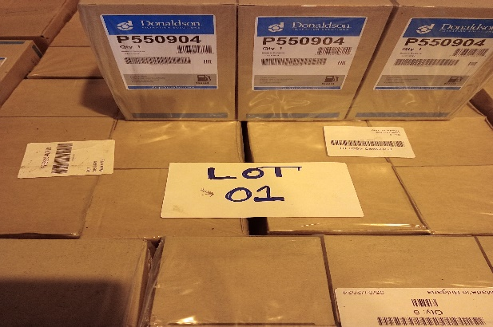
LOT NO. 2 | MOBILE PHONES (BUTTON)  - 12 ctns  Model: A5G/DUAL SIM  Qty: 50pcs  BILL OF LANDING: HKGBNE597853V | BEMOBILE | Pallet  (12 CTNS) | 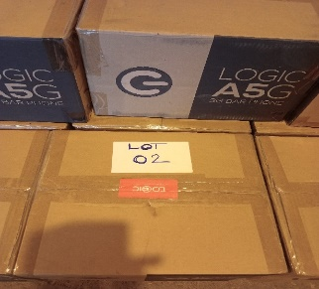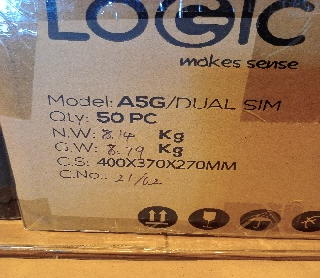
LOT NO. 3 | MOBILE PHONES (BUTTON)  - 12 ctns  Model: A5G/DUAL SIM  Qty: 50pcs  BILL OF LANDING: HKGBNE597853V | BEMOBILE | Pallet  (12 CTNS) | 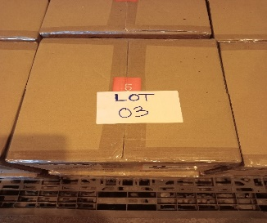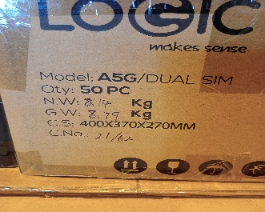
LOT NO. 4 | MOBILE PHONES (BUTTON)  - 12 ctns  Model: A5G/DUAL SIM  Qty: 50pcs  BILL OF LANDING: HKGBNE597853V | BEMOBILE | Pallet  (12 CTNS) | 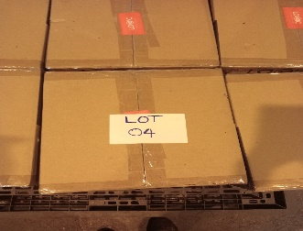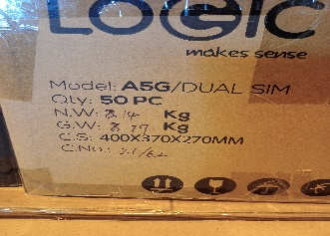
LOT NO. 5 | POTS & FRYING PAN, BABY STROLLER, TONER  - Pots & Frying pan (5 ctns)  - Baby stroller (2 ctns)  - Toner (1 ctn)  BILL OF LANDING: SLM02 | HENDERSON LOGISTICS PREFERRED SUPPLIES | Pallet  (8 CTNS) | 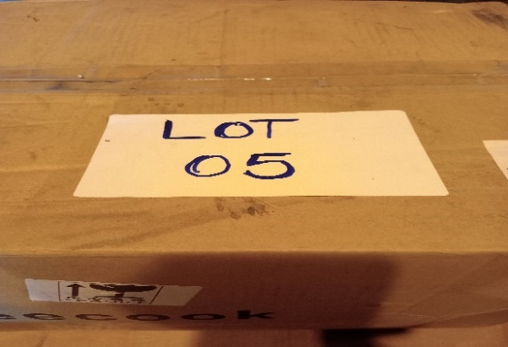
LOT NO. 6 | BULK COIN BAGS  - 43 ctns (250bags/ctn)  BILL OF LANDING: 90195 | CBSI | Pallet  (43 CTNS) | 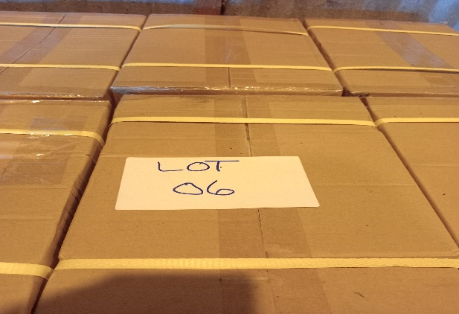
LOT NO. 7 | MOBILE PHONES (BUTTON)  - 10 ctns  Model: A5G/DUAL SIM  Qty: 50pcs  BILL OF LANDING: HKGBNE597853V | BEMOBILE | Pallet  (10 CTN) | 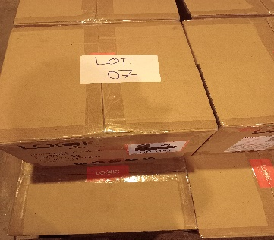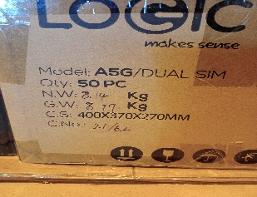
LOT NO. 8 | 4FT LOTTO SQAURE POP-UP GOAL AND FUTSAL BALLS)  - 7 X CTNS (Lotto Square pop-up goal)  - 2 X CTNS (Futsal Balls)  BILL OF LANDING: 92325 | SIFF | Pallet  (9 CTNS) | 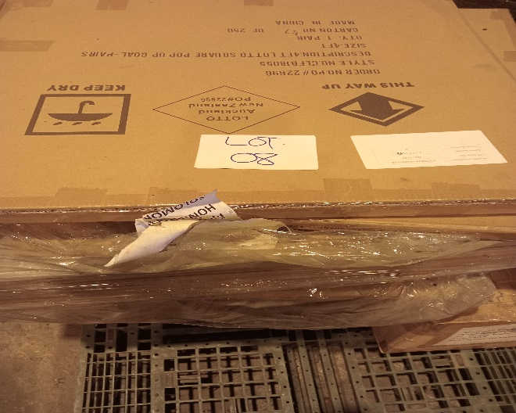
LOT NO. 9 | EPIGLUES  - 1 X Pallet | UNMANIFEST | Pallet  (1 PCS) | 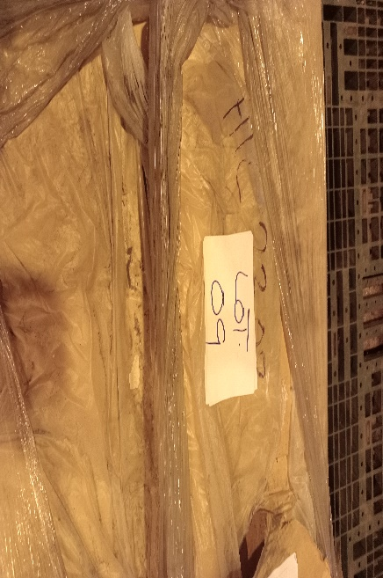
LOT NO. 10 | TREADMILL EQUIPMENT  - 1 X PALLET  B/LANDING: S00129773 | DAVID BATAANISIA | Pallet  (1 PCS) | 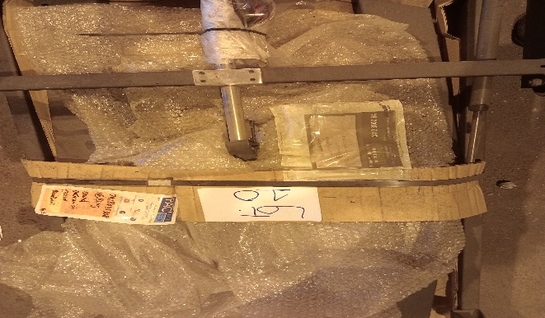
LOT NO. 11 | 8 PCS PUS X 295/35 TYRES  - BRAND: Minnell | PREVIOUS TENDER | Pallet  (8 PCS) | 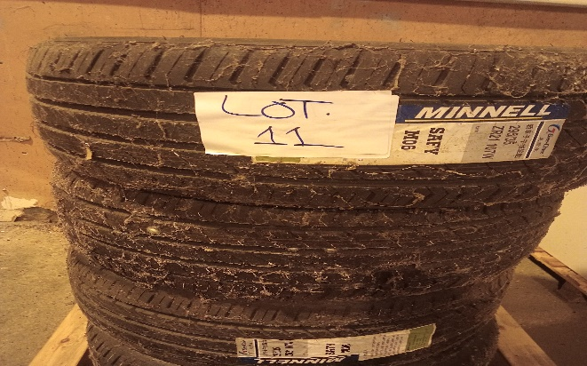
LOT NO. 12 | SOLAR CABLES (ASSORTED)  - 1 X Pallet  BILL OF LANDING: BNEHIR4471152V | KINGZLEY AWA KINGZAWAH ENT | Pallet  (1 PCS) | 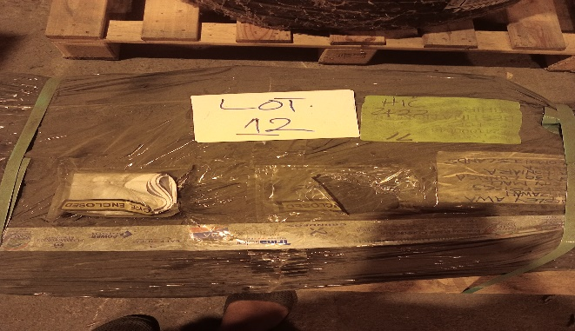
LOT NO. 13 | ASSORTED ELECTRICAL MACHINERIES PARTS  - Industrial Battery charger  - Maj link  - Various CnRangers subscriber Module | SOLOMON TOBACCO | Pallet  (5 CTNS) | 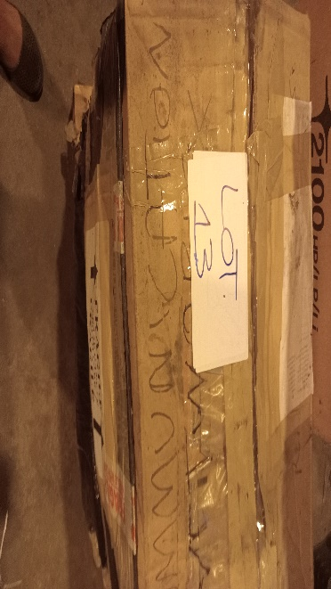
LOT NO. 14 | COSMETIC LAMP STAND  - 5 CTNS | SOLOMON TOBACCO | Pallet  (5 CTNS) | 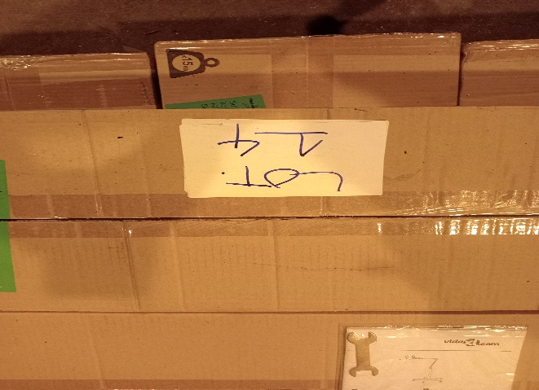
LOT NO. 15 | CABINET | UNMANIFEST | Pallet  (2 PCS) | 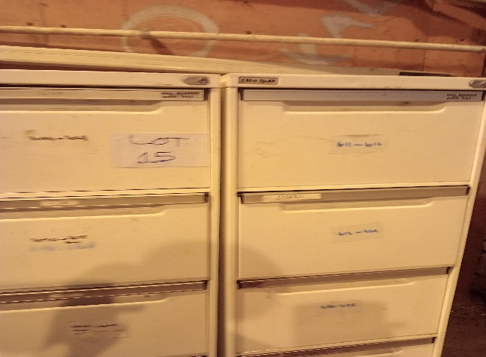
LOT NO. 16 | SECONDHAND CLOTHES  - 5 X FARMER BAGS  (MIX MENS SHIRTS, KIDS CLOTHES) | UNMANIFEST | Pallet  (5 PCS) | 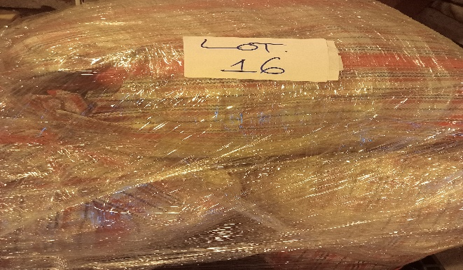
LOT NO. 17 | SECONDHAND CLOTHES  - 5 X FARMER BAGS  (KIDS/ LADIES/ MEN CLOTHES) | UNMANIFEST | Pallet  (5 PCS) | 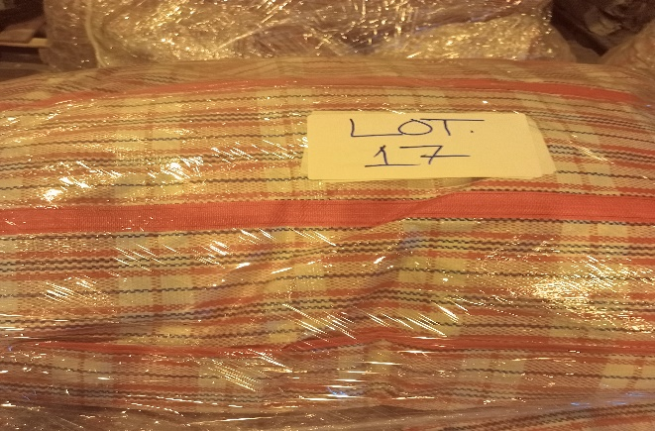
LOT NO. 18 | 1 X 7 DRAWER ROLLER CABINET & 1 X 8 DRAWER ROLLER CABINET | SOLOMON TOBACCO | Pallet  (5 PCS) | 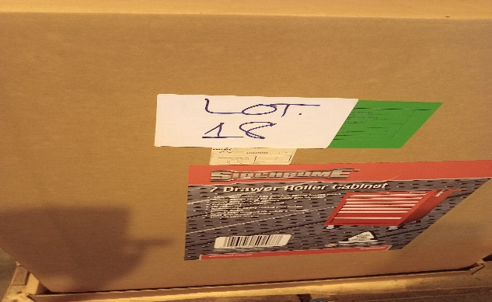
LOT NO. 19 | ENERGY STORAGE BATTERY  BILL OF LANDING: SLM02-43 | HENDERSON LOGISTICS LTD | 1 PCS | 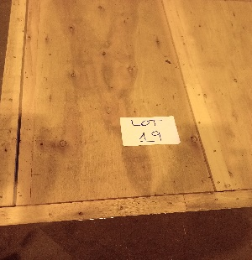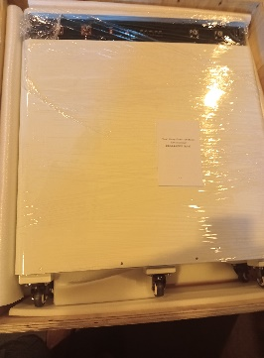
LOT NO. 20 | ENERGY STORAGE BATTERY  BILL OF LANDING: SLM02-43 | HENDERSON LOGISTICS LTD | 1 PCS | 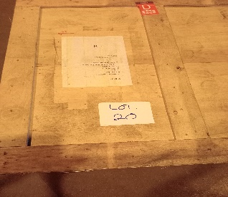
LOT NO. 21 | SECONDHAND CLOTHES  - 5 X FARMER BAGS  (KIDS/ MENS/ LADIES CLOTHES) | UNMANIFEST | Pallet  (5 PCS) | 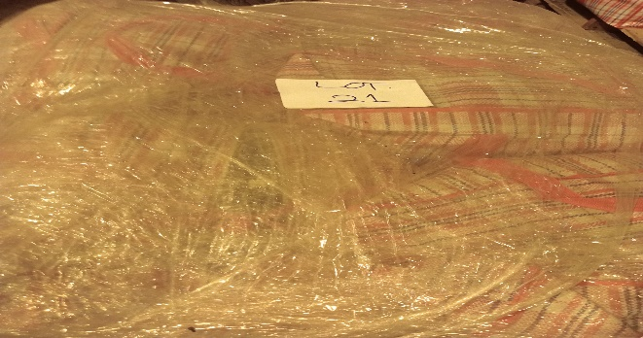
LOT NO. 22 | SECONDHAND CLOTHES  - 5 X FARMER BAGS  (MENS/ WOMENS/KIDS CLOTHES) | UNMANIFEST | Pallet  (5 PCS) | 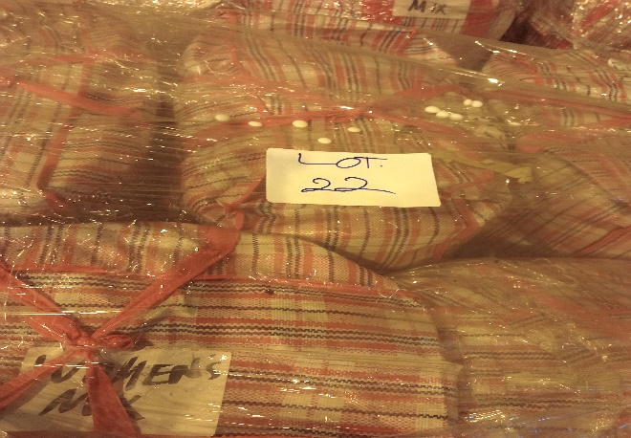
LOT NO. 23 | SECONDHAND CLOTHES  - 5 X FARMER BAGS  (MENS/ WOMENS/KIDS CLOTHES) | UNMANIFEST | Pallet  (5 PCS) | 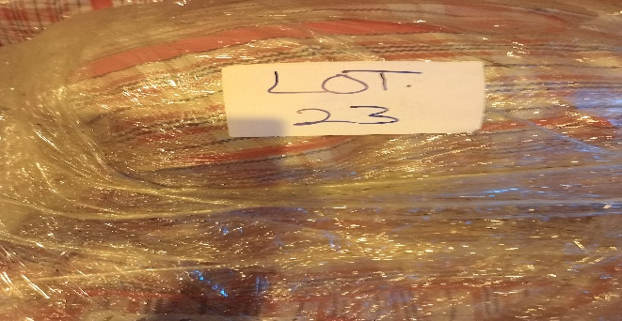
LOT NO. 24 | SECONDHAND CLOTHES  - 5 X FARMER BAGS  (MENS/ WOMENS/KIDS CLOTHES) | UNMANIFEST | Pallet  (5 PCS) | 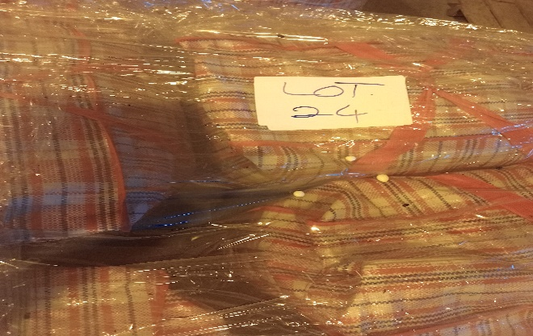
LOT NO. 25 | SECONDHAND CLOTHES  - 5 X FARMER BAGS  (MENS/ WOMENS/KIDS CLOTHES) | UNMANIFEST | Pallet  (5 PCS) | 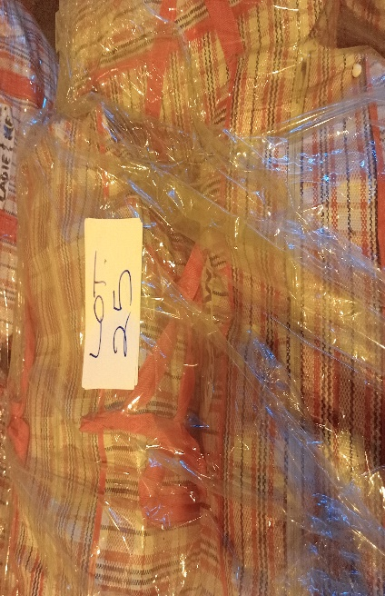
LOT NO. 26 | SECONDHAND CLOTHES  - 5 X FARMER BAGS  (MENS/ WOMENS/KIDS CLOTHES) | UNMANIFEST | Pallet  (5 PCS) | 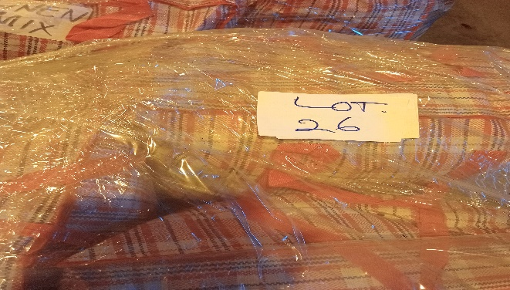
LOT NO. 27 | SECONDHAND CLOTHES  - 5 X FARMER BAGS  (MENS/ WOMENS/KIDS CLOTHES) | UNMANIFEST | Pallet  (5 PCS) | 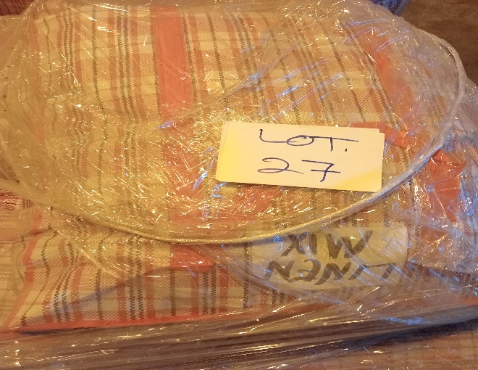
LOT NO. 28 | SECONDHAND CLOTHES  - 5 X FARMER BAGS  (MENS/ WOMENS/KIDS CLOTHES) | UNMANIFEST | Pallet  (5 PCS) | 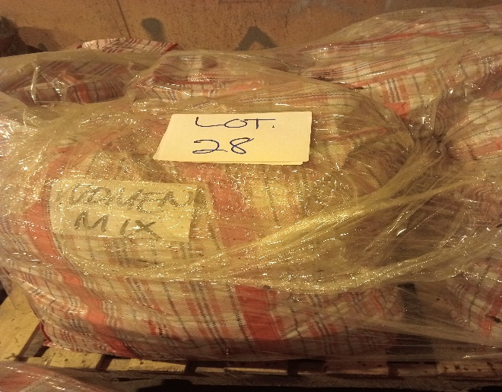
LOT NO. 29 | SECONDHAND CLOTHES  - 5 X FARMER BAGS  (MENS/ WOMENS/KIDS CLOTHES) | UNMANIFEST | Pallet  (5 PCS) | 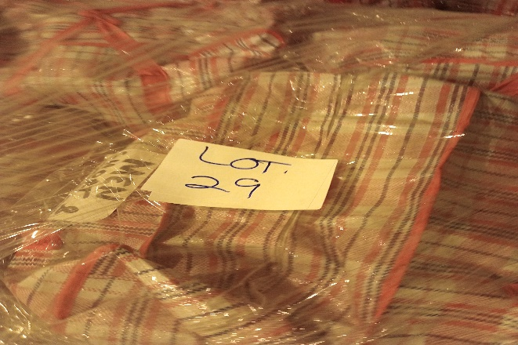
LOT NO. 30 | SECONDHAND CLOTHES  - 5 X FARMER BAGS  (MENS/ WOMENS/KIDS CLOTHES) | UNMANIFEST | Pallet  (5 PCS) | 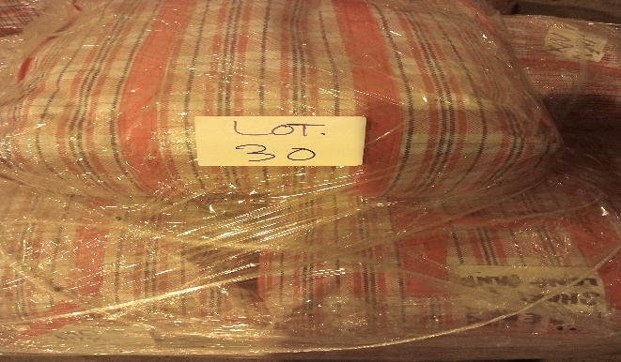
LOT NO. 31 | TOYOTA CALDINA VAN  BILL OF LADING NO:476165NGO017 | FRED OLI | 1 UNIT | 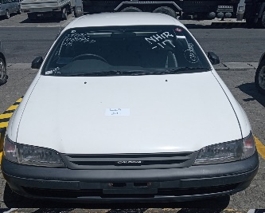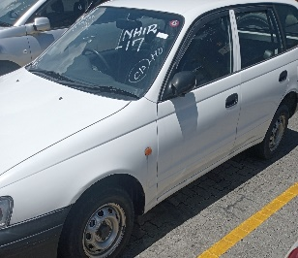
KINGSWAREHOUSE TWO (2)
LOT NO. 32 | YAMAHA RAY BOAT (WITH YAMAHA ENDURO 40HP ENGINE)  Excluding Trailer | PREVIOUS TENDER | 1 Boat  1 Engine | 