
CUSTOMS & EXCISE DIVISION, P.O. BOX G16, HONIARA SOLOMON ISLANDS
MINISTRY OF FINANCE AND TREASURY

TO: COMPTROLLER OF CUSTOMS & EXCISE

I/We the undersigned offer to purchase the stated Lot/lots at the tender price of

In Words………………………………………………………………………………………………$SBD………………………………….

Date this: …………………………………………….… day of…………………………………….………………………………2023

Full Name: ……………………………………………………………………………………………………………………………………….

Signature: …………………………………………

Company (If applicable): ………………………………………………………………………………………………………………...

PROPOSED TENDER LIST
AS AT September 2023
KINGS WAREHOUSE ONE
LOT NO. | DESCRIPTIONS | PIECES PER CTN | QUANTITY | IMAGES | Proposed Tender Amount ($)
LOT NO. 1 | MAKITA CIRCULAR SAW  235MM (9 – ¼”),  MODEL: N5900B | 1 CTN | 2PCS/CTN | 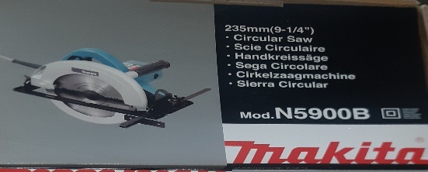
LOT NO. 2 | MAKITA CIRCULAR SAW  235MM (9 – ¼”),  MODEL: N5900B | 1 CTN | 2PCS/CTN | 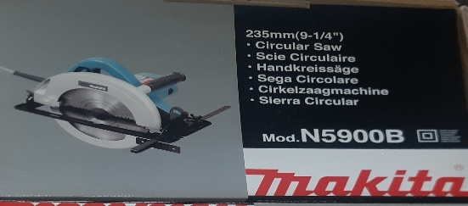
LOT NO. 3 | MAKITA CIRCULAR SAW  235MM (9 – ¼”),  MODEL: N5900B | 1 CTN | 2PCS/CTN | 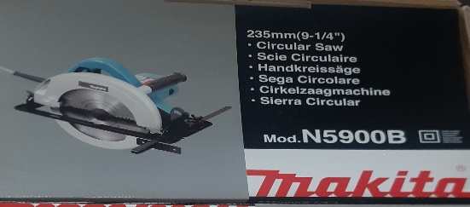
LOT NO. 4 | MAKITA CIRCULAR SAW  185MM (7 – 7/4’’) – 190MM (7 – ½’’)  MODEL: M5802B | 1 CTN | 1PCS/CTN | 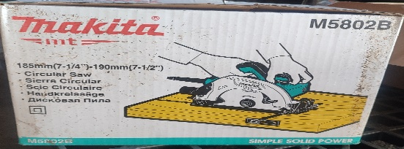
LOT NO. 5 | MAKITA CIRCULAR SAW  185MM (7 – 7/4) – 190MM (7 – ½)  MODEL: M5802B | 1 CTN | 1PCS/CTN | 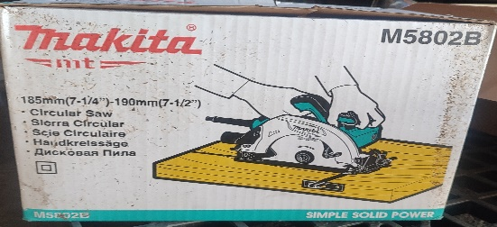
LOT NO. 6 | DONG CHENG BELT SANDER  S1T – FF – 100 X 610, DONG CHENG, 220V 50HZ | 1 CTN | 3 PCS/CTN | 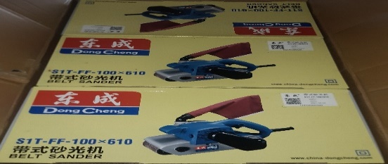
LOT NO. 7 | DONG CHENG BELT SANDER  S1T – FF – 100 X 610,  220V 50HZ | 1 CTN | 3PCS/CTN | 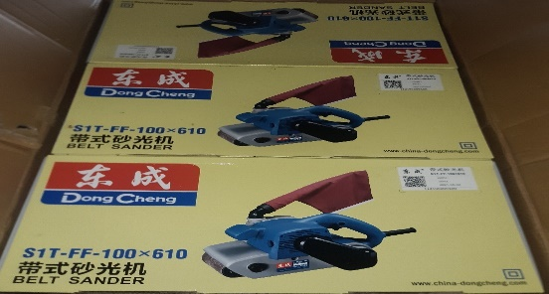
LOT NO. 8 | MAKITA BELT SANDER  MODEL: M9400B  (100MM – 4”) | 1 CTN | 2PCS/CTN | 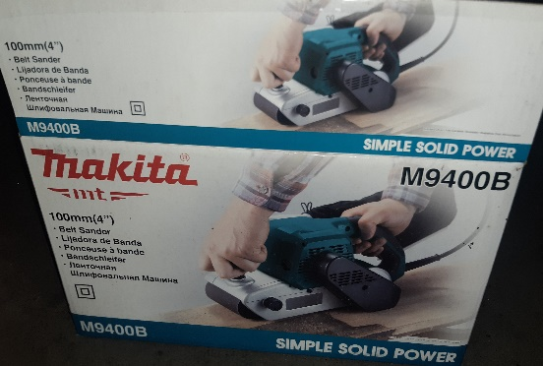
LOT NO. 9 | MAKITA BELT SANDER  MODEL: M9400B  (100MM – 4”) | 1 CTN | 2PCS/CTN
LOT NO. 10 | MAKITA ANGLE GRINDER  MODEL: M0910B (100 MM (4”)) | 1 CTN | 8PCS/CTN | 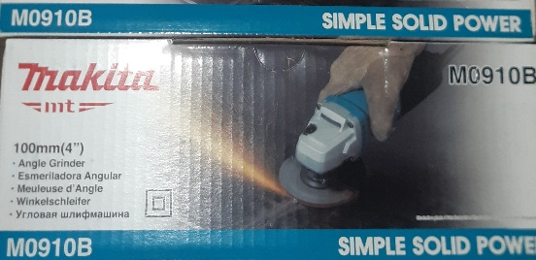
LOT NO. 11 | MAKITA ANGLE GRINDER  MODEL: M0910B (100 MM (4”)) | 1 CTN | 8PCS/CTN
LOT NO. 12 | MAKITA ROUTER  MODEL: M3600B  ROUTER BLADE: S20 =22 PIECES, S32 = 12 PIECES, S40 = 2 PIECES, S49= 10 PIECES, S50=12 PIECES  1 X SET BOX ROUTER | 3 CTNS + 1 BOX ROUTER | 4PCS | 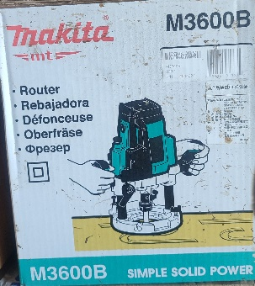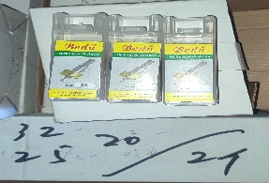
LOT NO. 13 | MOBILE POWER BANK  LSB BACKUP POWER | 2 CTN | 142PCS  70PCS/CTN  72PCS/CTN | 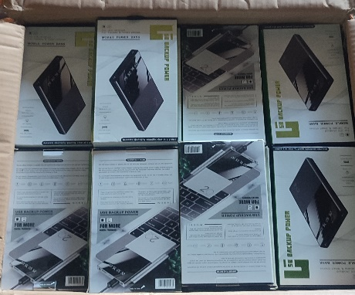
LOT NO. 14 | MOBILE PHONE- 10.52  WITHOUT  SCREEN AND BATTERY  (EMPTY MOBILE PHONE BODY) | 1 CTN | 50PCS/CTN | 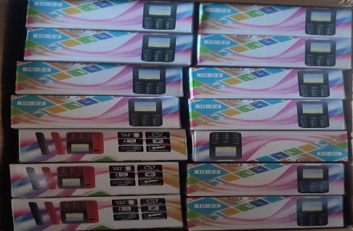
LOT NO. 15 | MOBILE PHONE- NOKIA C5 PRO | 1 CTN | 32PCS/CTN | 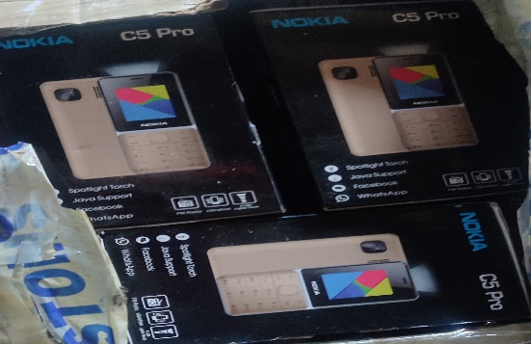
LOT NO. 16 | KITCHENWARE  FRYING PAN, BARBECUE SPOON  PLATE TRAY | 2 CTN | 2 CTN | 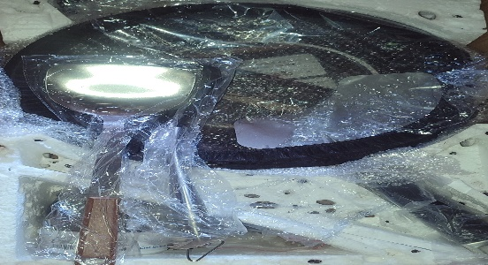
LOT NO. 17 | MIX ITEMS  3 X CCTV CAMERA, CS – C5 W/AGA (4G, 1080P, 4MM)  1 X CCTV CAMERA HIK VISION, SMART 265, 4G  1 X CCTV CAMERA E2VIZ, C8HC, 1080P, 4MM  1 X HUAWEI HILINK – WIFI  4 PIECES NUTS  11 X PCS MONITOR CHARGER | 1 CTN | 21PCS | 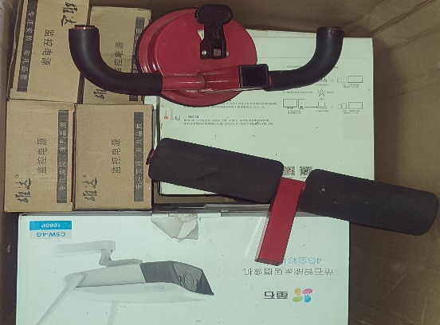
LOT NO. 18 | WINDOW SHIELD SIDE FRAME  (10-2 X 1.8M)  80PCS/CTN | 3 CTN | 240PCS/3CTN | 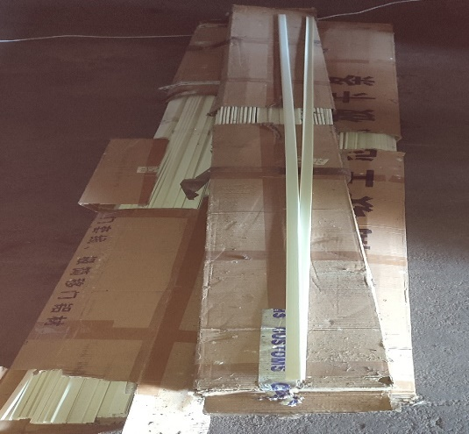
LOT NO. 19 | CONTAINER SEAL | 12 CTN | 12 CTN | 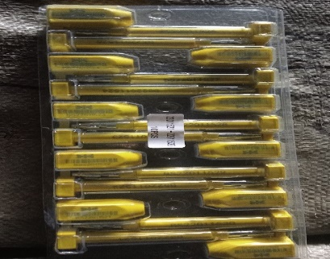
LOT NO. 20 | 2 PCS BUMPER – FRONT AND BACK  1 PCS MUFFLER  10 PCS BELT  4 PCS- XPA907, 1836 CS 035 036 037  6 PCS- XPA882, A200 31 32 33  2 PCS TYRE COVER | 1 SET | 6PCS | 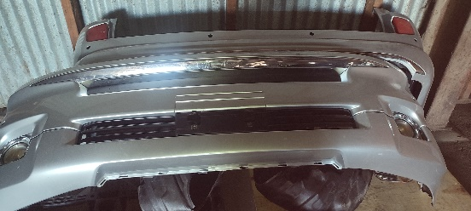
LOT NO. 21 | TYRE (295/35) ZR21 107W | SET | 4PCS/SET | 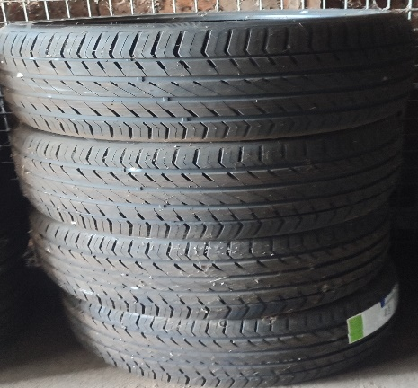
LOT NO. 22 | TYRE (295/35) ZR21 107W | SET | 4PCS/SET | 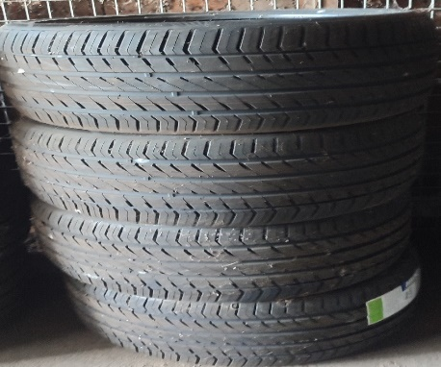
LOT NO. 23 | TYRE (295/35) ZR21 107W | SET | 4PCS/SET | 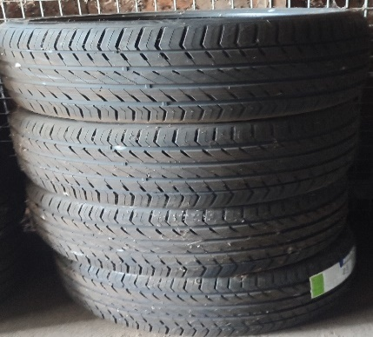
LOT NO. 24 | SECATEURS  5 CTN = 60PC/CTN | 5 CTN | 300PCS/5 CTN | 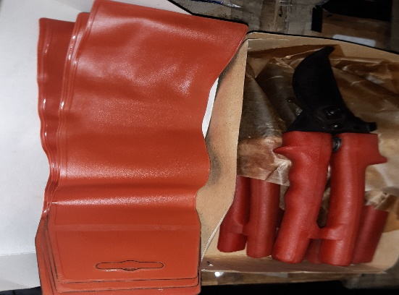
LOT NO. 25 | TONGUE & GROVE HINGE | 1 BAG |  | 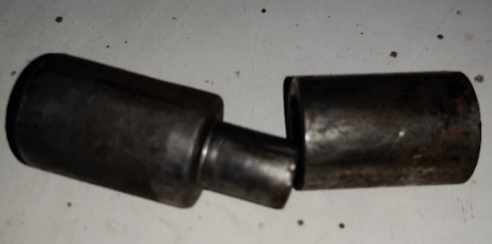
LOT NO. 26 | PLASTIC BAG | 1 BAG |  | 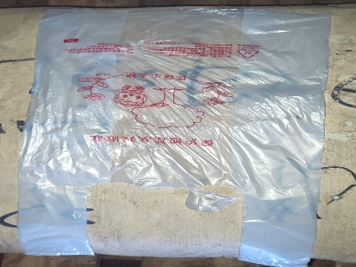
LOT NO. 27 | CERAMIC SINK | 2 CTN | 2PCS  1PCS/CTN | 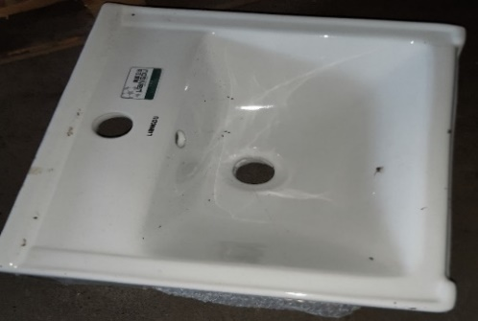
LOT NO. 28 | COTTON ROPE | 2 CTN | 40PCS  20PCS/CTN | 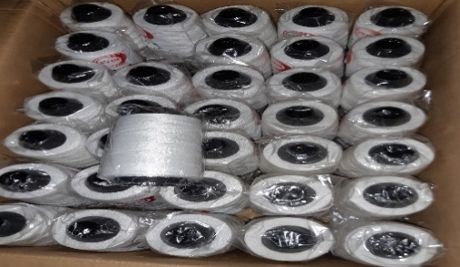
LOT NO. 29 | FSL LIGHT BULB T8 (25PCS)  FSL LIGHT BULB FRAME (25PCS)  16 WATTS  (1255 X 156 X 156MM3)  25PCS/CTN | 2 CTN | 25 SET | 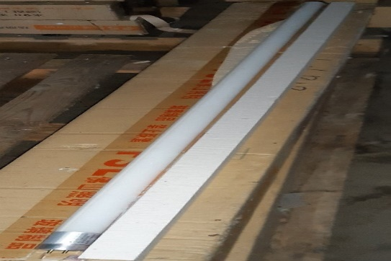
LOT NO. 30 | FSL LIGHT BULB T8  FSL LIGHT BULB FRAME  7 WATTS  (645 X 156 X 156 MM3)  25PC/CTN | 10 CTN | 125 SET | 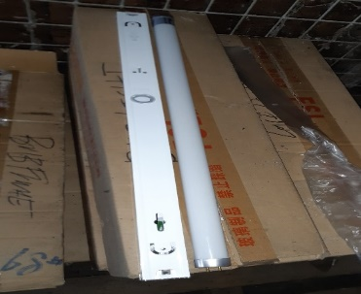
LOT NO. 31 | FSL LIGHT BULB (PIN)  5 WATTS, B22  (440 X 225 X 150 MM3) | 2 CTN | 100PCS  50PCS/CTN | 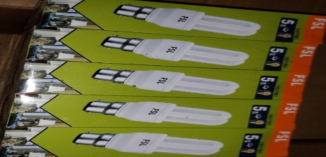
LOT NO. 32 | CASH REGISTER SYSTEM  3 THERMAL BARCODE MINI PRINTER  3 BAR CODE BLUETOOTH SPP | 3 CTN | 3 SET | 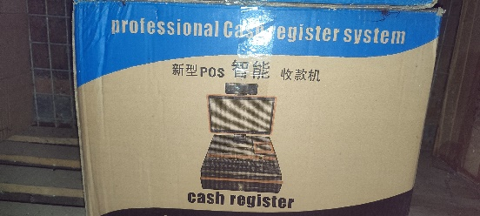
LOT NO. 33 | XG – 36 ROUND LED LIGHT  38 WATTS  AC220 – 240V – 50/60HZ | 2 CTN | 40PCS  20PCS/CTN | 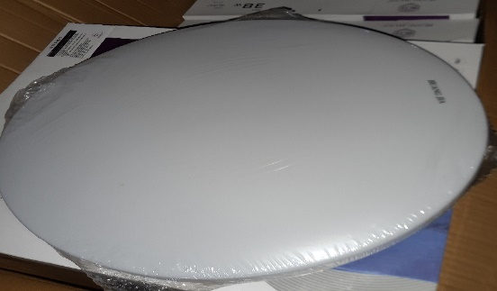
LOT NO. 34 | VEHICLE- ALLION  YOM:  MILEAGE:  ENGINE:  CHASIS:  MODEL: | 1 PCS | 1 UNIT | 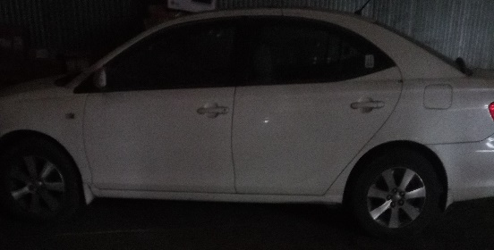
KINGS WAREHOUSE 2

LOT NO.36 | BASKET BALLS  2 CTNS- 40PCS/CTN  1 CTN- 24PCS/CTN | 3 CTNS | 104PCS | 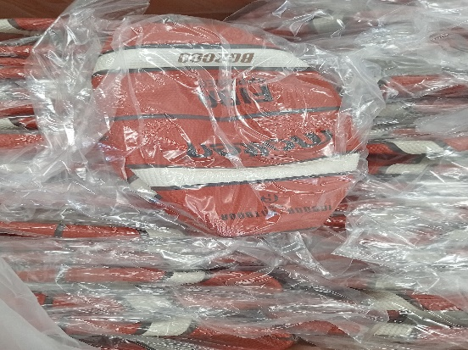
LOT NO.37 | FUTSAL BALLS  1 CTN  FUTSAL UNIFORM (11PAIRS)  FUSAL SCARF (10PCS)  SPORT SOCKS (7PAIRS)  CAPS (10PCS)  TRAINING CONES (18PCS)  1 CTN  USED FUTSAL BALLS (24PCS)  1 CTN  USED FUTSAL BALLS (10PCS) | 3 CTNS |  | 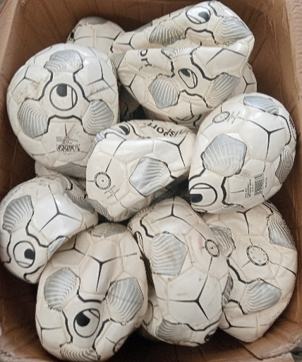
LOT NO.38 | PLASTIC LAUNDARY TRAY  MEA: 43 X 32 X 26CM  1 CTN= 26PC + PLASTIC DISPOSAL CUPS= 14PKG, 90PCS/PKG, 90ML | 1 CTNS | 26PCS/CTN | 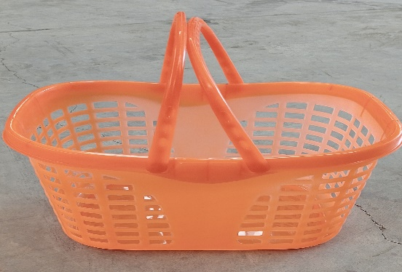
LOT NO.39 | PLASTIC LAUNDARY TRAY  MEA: 37.5 X 28 X 22CM  1 CTN= 30PCS  1 CTN= 29PC + PLASTIC DISPOSAL CUPS= 12PKG, 90PKGS/PKG, 90ML | 2 CTN | 59PCS | 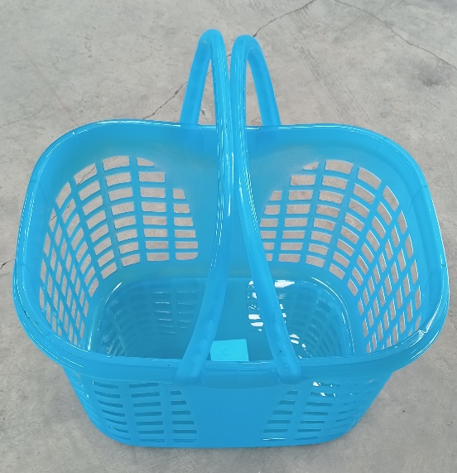
LOT NO.40 | PLASTIC STORAGE TRAY  1 CTN= 390PCS/CTN | 1 CTN | 390PCS | 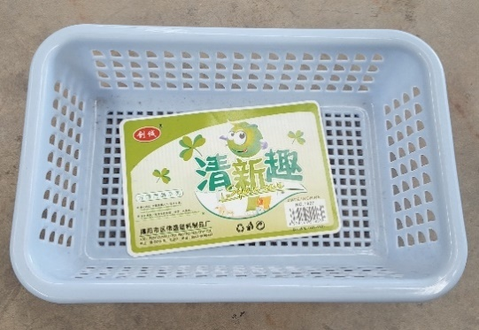
LOT NO.41 | AIR VISUAL OUTDOOR | 1 CTN | 6PCS/CTN | 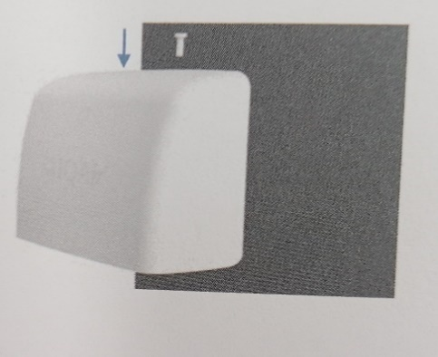
LOT NO.42 | CAMERA STAND (9PCS) | 1 CTN | 9PCS | 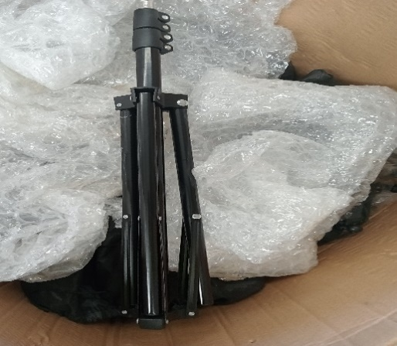
LOT NO.43 | AIR CONDITIONING COMPRESSOR + SAFETY EYE WEAR  1 CTN  ZAX60C-5A BOOM (19PCS)  ZAX200-5A BUCKET (40PCS)  1 CTN  SAFETY EYE WEAR (140PCS)  CORDED REUSUABLE EAR PLUGS (4 CTN) | 2 CTN | 2 CTN | 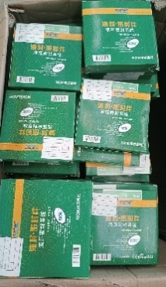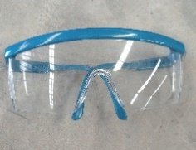
LOT NO.44 | BABY WALKER  1 CTN= 7PCS | 3 CTN | 21PCS | 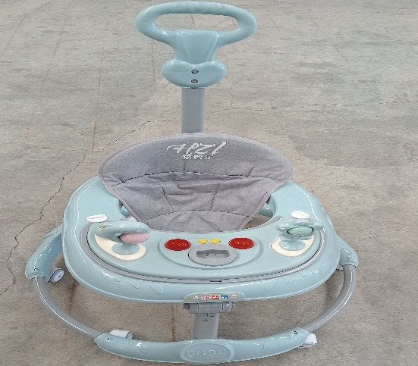
LOT NO.45 | PLASTIC KIDS BALLS  2 CTN= 300PCS EACH  1 CABBAGE PLASTIC BAG= 140PCS | 3 CTN | 540PCS | 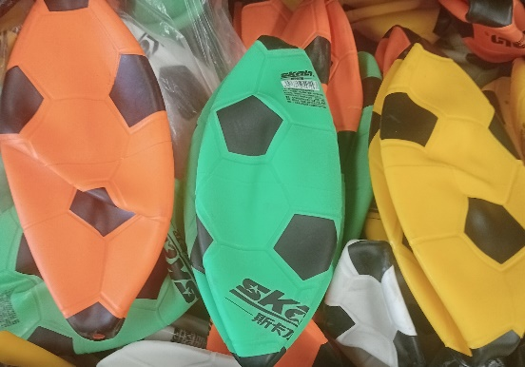
LOT NO.46 | BABY WALKER  6PCS/CTN | 10 CTN | 60PCS | 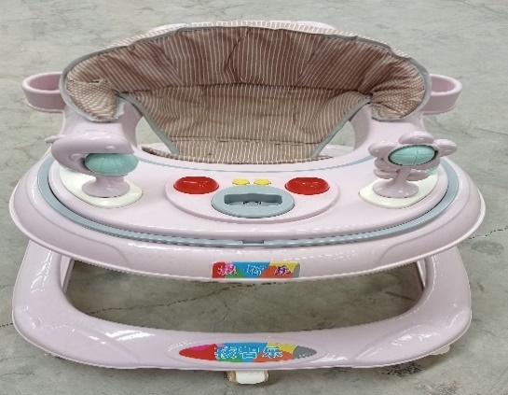
LOT NO.47 | USED TYRE  LT 215/85 R16 | 6PCS |  | 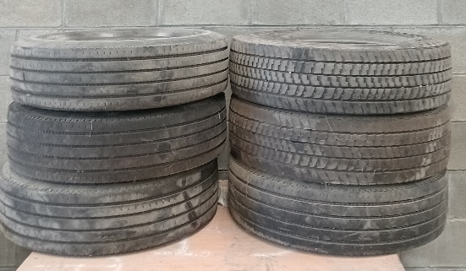
LOT NO.48 | USED TYRE  205/70 R15 (2PCS) | 2PCS |  | 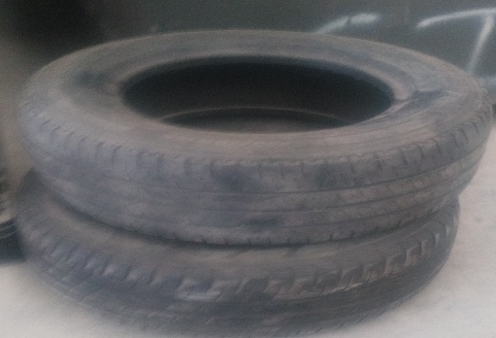
LOT NO.49 | EXPANDENT (PLUG TAGO DUBEL TASSELLI CHEVILLE)  20PKG/CTN  20 6M/M | 2 CTN | 40PKG  20PKG/CTN | 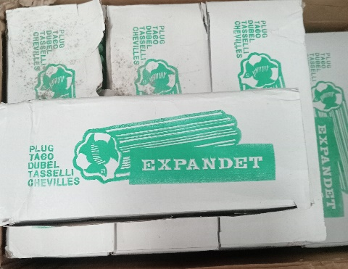
LOT NO.50 | WELDING ELECTRODE  2.5 X 300MM | 2 CTN |  | 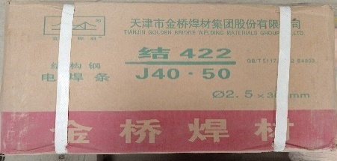
LOT NO.51 | WELDING ELECTRODE  3.2 X 350MM | 2 CTN |  | 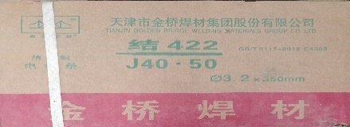
LOT NO.52 | DART SET  2 x Dart board  1 x Dart arrow (20G) | SET |  | 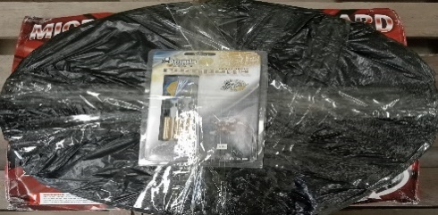
LOT NO.53 | ARCHERY SET | SET |  | 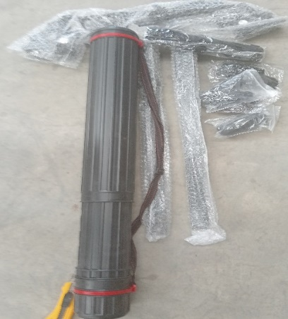
LOT NO.54 | SQUATTING PAN | 20 CTN | 20PCS  1PCS/CTN | 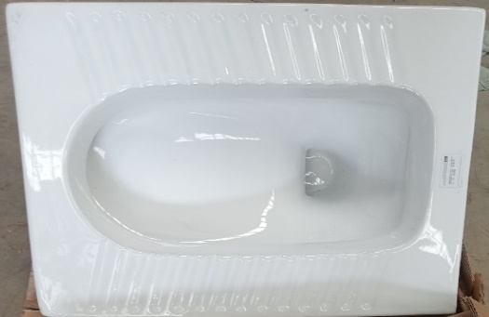
LOT NO.55 | CABLE  COMMUNICATON CABLE  1000FT  305MTR | 1 ROLL |  | 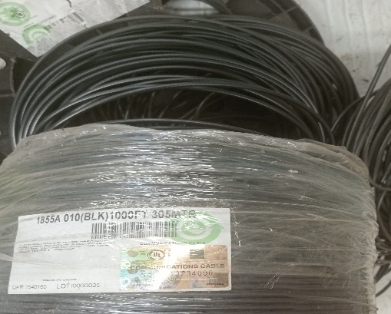
LOT NO.56 | PLYWOOD | 11 PCS | 11 PCS | 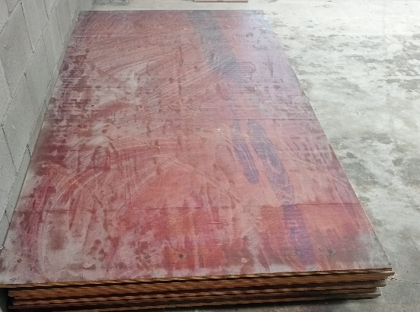
LOT NO.57 | FOG MACHINE  4PCS/CTN | 41 CTN | 164PCS  4PCS/CTN | 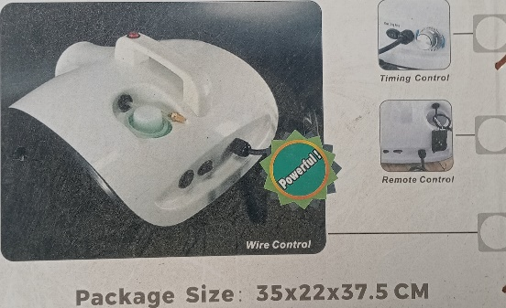
LOT NO.58 | SURFACE MOUNTED BASE | 1 CTN | 100PCS | 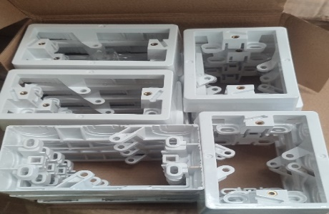
LOT NO.59 | FACE MASK | 8 CTN |  | 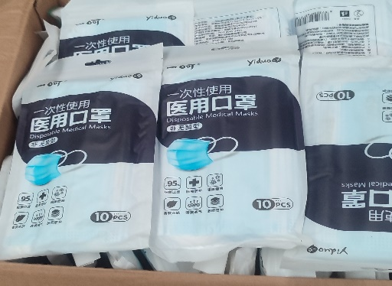
LOT NO.60 | OIL FILTER (46PCS)  OIL FILTER C-5715 (5PCS)  OIL FILTER C-6204 (5PCS)  OIL FILTER C-1004 (5PCS)  FUEL/WATER SEPARATOR SFC- 5706 (5PCS)  FUEL FILTER FC-1022 (5PCS)  FUEL FILTER FC-1004 (5PCS)  FLEET GUARD FF 105D (2PCS)  FLEET GUARD F5 1280 (4PCS)  FLEET GUARD FF 105 (5PCS)  FLEET GUARD F5 1251 (5PCS) | 1 CTN | 47PCS | 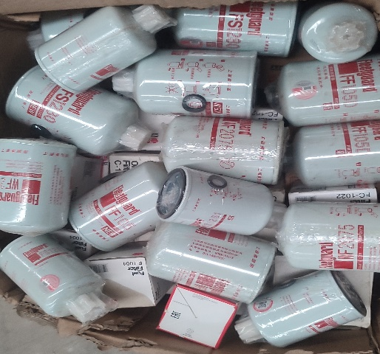
LOT NO.61 | PHONE COVERS (91PCS)  +  TEMPER SCREEN (10PCS) | 1 CTN | 101PCS | 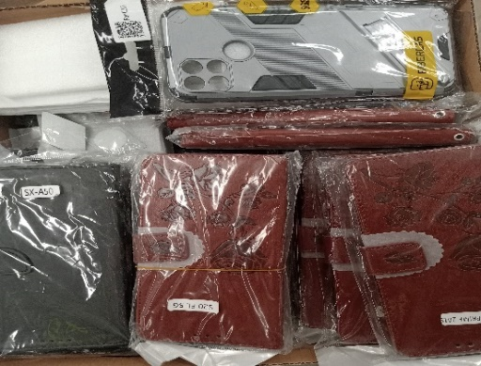
LOT NO.62 | MOBILE PHONES BOX#1 (5PCS)  HONOR- 2PCS  MI- 2PCS  MEIZU- 1PCS | 1 CTN | 5 PCS | 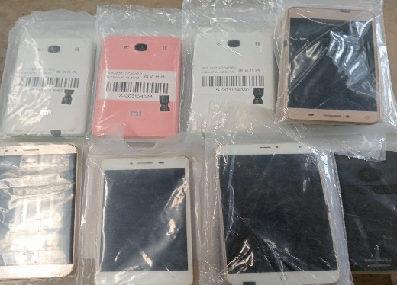
LOT NO.63 | MOBILE PHONES BOX#2 (5PCS)  HONOR- 1PCS  MI- 2PCS  MEIZU- 1PCS  SAMSUNG- 1PCS | 1 CTN | 5 PCS | 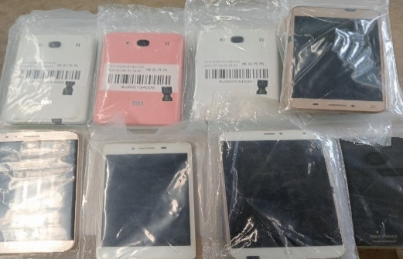
LOT NO.64 | MOBILE PHONES BOX#3 (5PCS)  HONOR-1PCS  MI- 2PCS  MEIZU- 1PCS  VIVO- 1PCS | 1 CTN | 5 PCS
LOT NO.65 | MOBILE PHONES BOX#4 (5PCS)  HONOR- 1PCS  MI- 2PCS  MEIZU- 1PCS  HUAWEI- 1PCS | 1 CTN | 5 PCS | 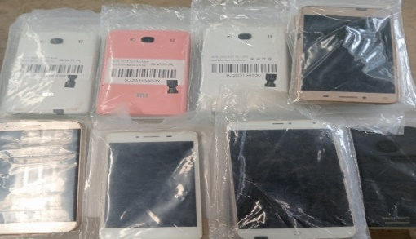
LOT NO.66 | GEN SET  250KVL  CONTROL BOX | SET | 1 PCS | 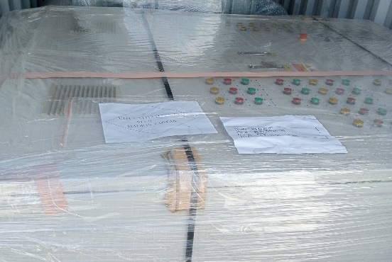

All tenders must include the following details:
Full name of tenderer:
Contact phone number:
Email address:
Evidence of sufficient bank funds to cover tender bid
Checklist – Have you submitted the following?
CHECKLIST
Check that you have included all the documents in your tender here:
Send copies only, not original
1 | Tender Form | Yes | No
2 | Proof of Finance (Bank statement) | Yes | No
3 | Company Registration if not an individual | Yes | No

